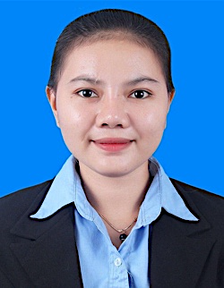**CURRICULUM VITAE**

**KORY sinav**

Tel: +855(0) 77 589 939/ +855(0) 93 888 374

Domnak5 Village, Songkat Stengmeanjey3, Khan Meanjey, Phnom Penh

Email : navn8434@gmail.com

Position :

**PERSONAL DETAIL**

Nationality : Cambodia

Gender : Female

Marital State : Single

Date of Birth : May-13-2000

Place of Birth : Somrong Yea commune, Pouk District, Siem Reap Province

**EDUCATION**

2019-Now : Study at Royal University (Second Years)

2019 : studied at PANASATRA University

2016-2018 : studied at Pouk High School

2013-2015 : studied at Donsva Secondary School

**SKILL**

Computer Skill : Microsoft Word, Microsoft PowerPoint, Excel

Soft Skill : Time Communication, Management Time, responsibility

**Language**

English : Good (writing, Speaking, listening)

Khmer : Mother tongue

**HOBBIE** : meet new people, Research, Find a new one

**REFERENCE**

MR. Hen koy

Position : Lecturer of Physic in Royal university

Tell : +855(0) 12 376 392